Bank Loan Report | Summary

KPI’s:

Total Loan Applications:

- Select count(id) as total_loan_application from bank_loandata;

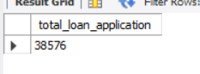

MTD Loan Applications:

- SELECT count(id) as MTD_total_loan_application FROM bank_loandata
WHERE month(str_to_date(issue_date, '%d-%m-%Y')) = 12
and year(str_to_date(issue_date, '%d-%m-%Y')) = 2021;

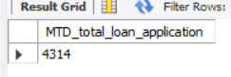

PMTD Loan Application:

- SELECT count(id) as PMTD_total_loan_application FROM bank_loandata
WHERE month(str_to_date(issue_date, '%d-%m-%Y')) = 11
and year(str_to_date(issue_date, '%d-%m-%Y')) = 2021;

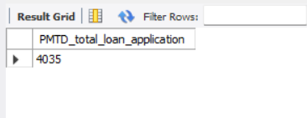

MTD Total Funded Amount

- Select sum(loan_amount) as MTD_total_fundedamount
from bank_loandata
where month(str_to_date(issue_date, '%d-%m-%Y')) = 12
and year(str_to_date(issue_date, '%d-%m-%Y')) = 2021;

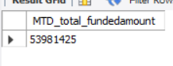

PMTD Total Funded Amount

- Select sum(loan_amount) as PMTD_total_fundedamount
from bank_loandata
where month(str_to_date(issue_date, '%d-%m-%Y')) = 11
and year(str_to_date(issue_date, '%d-%m-%Y')) = 2021;

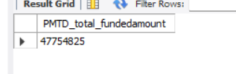

Total Funded Amount

- Select sum(loan_amount) as total_fundedamnt
from bank_loandata;

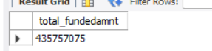

Total Amount Received

- Select sum(total_payment) as total_amt_received
from bank_loandata;

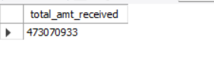

MTD Total Amount Received

- Select sum(total_payment) as MTD_total_amtreceived
from bank_loandata
where month(str_to_date(issue_date, '%d-%m-%Y')) = 12
and year(str_to_date(issue_date, '%d-%m-%Y')) = 2021;

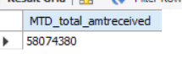

PMTD Total Amount Received

- Select sum(total_payment) as PMTD_total_amtreceived
from bank_loandata
where month(str_to_date(issue_date, '%d-%m-%Y')) = 11
and year(str_to_date(issue_date, '%d-%m-%Y')) = 2021

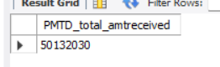

Average Interest Rate

- Select round(avg(int_rate) * 100,2) as Average_Interestrate
from bank_loandata;
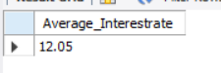
MTD Average Interest Rate

- Select round(avg(int_rate) * 100,2) as MTD_Average_interestrate from bank_loandata
where month(str_to_date(issue_date, '%d-%m-%Y')) = 12 and year(str_to_date(issue_date, '%d-%m-%Y')) = 2021;

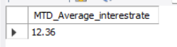

PMTD Average Interest Rate

- Select round(avg(int_rate) * 100,2) as PMTD_Average_interestrate from bank_loandata
where month(str_to_date(issue_date, '%d-%m-%Y')) = 11 and year(str_to_date(issue_date, '%d-%m-%Y')) = 2021;

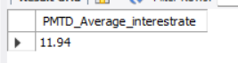

Average DTI

- Select avg(dti) * 100 as Avg_DTI
from bank_loandata;

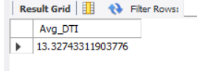

MTD_Average DTI
- select avg(dti) * 100 as MTD_Avg_DTI
from bank_loandata
where
month(str_to_date(issue_date, '%d-%m-%Y')) = 12 and
year(str_to_date(issue_date, '%d-%m-%Y')) = 2021

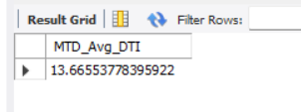
PMTD_Average DTI
- select avg(dti) * 100 as PMTD_Avg_DTI
from bank_loandata
where
month(str_to_date(issue_date, '%d-%m-%Y')) = 11 and
year(str_to_date(issue_date, '%d-%m-%Y')) = 2021

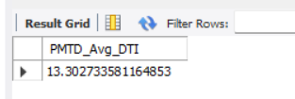

Good Loan Issued

Good Loan Percentage
- Select round((Count(case when loan_status = 'Fully Paid' or loan_status = 'Current' then id end) * 100)
/
count(id), 0) as Good_loan_percentage
from bank_loandata;

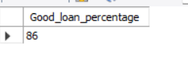

Good LoanApplication
- Select count(id) as Good_LoanApplication from bank_loandata
where loan_status = 'Fully Paid' or loan_status = 'Current';

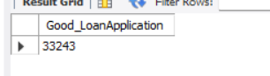

Good Loan FundedAmount
- Select sum(loan_amount) as Good_loan_fundedamount from bank_loandata
where loan_status = 'Fully Paid' or loan_status = 'Current';

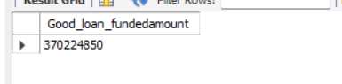

Good Loan ReceivedAmount
- Select sum(total_payment) as Good_loan_receivedamnt from bank_loandata
where loan_status = 'Fully Paid' or loan_status = 'Current';

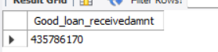

Bad Loan Issued

Bad Loan Percentage
20) Select round(count(case when loan_status = 'Charged Off' then id end) * 100 /
count(id),2) as bad_loan_pct
from bank_loandata;

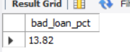

Bad Loan Application
- Select count(id) as bad_loan_application from bank_loandata
where loan_status = 'Charged Off';

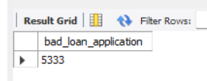

Bad Loan Funded Amount
- Select sum(loan_amount) as bad_loan_fundedamt from bank_loandata
where loan_status = 'Charged Off';

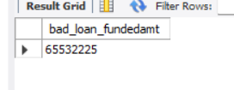

Bad Loan Received Amount
- Select sum(total_payment) as bad_loan_amountreceived from bank_loandata
where loan_status = 'Charged Off'

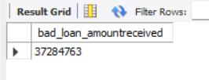

Loan Status

- Select loan_status, count(id) as total_applications,
sum(total_payment) as received_loanamnt,
sum(loan_amount) as total_fundedamnt,
avg(int_rate * 100) as interest_rate,
avg(dti * 100) as DTI
from bank_loandata
group by loan_status
order by total_applications desc;

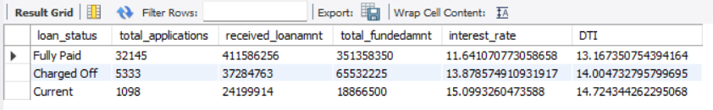

MTD Loan Issued

- Select loan_status, count(id) as total_applications,
sum(total_payment) as MTD_received_loanamnt,
sum(loan_amount) as MTD_total_fundedamnt,
avg(int_rate * 100) as interest_rate,
avg(dti * 100) as DTI
from bank_loandata
where month(str_to_date(issue_date, '%d-%m-%Y')) = 12
and year(str_to_date(issue_date, '%d-%m-%Y')) = 2021
group by loan_status
order by total_applications desc;

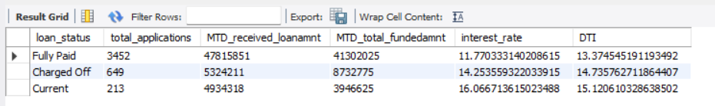
PMTD Loan Issued

- Select loan_status, count(id) as total_applications,
sum(total_payment) as PMTD_received_loanamnt,
sum(loan_amount) as P MTD_total_fundedamnt,
avg(int_rate * 100) as interest_rate,
avg(dti * 100) as DTI
from bank_loandata
where month(str_to_date(issue_date, '%d-%m-%Y')) = 11
and year(str_to_date(issue_date, '%d-%m-%Y')) = 2021
group by loan_status
order by total_applications desc;

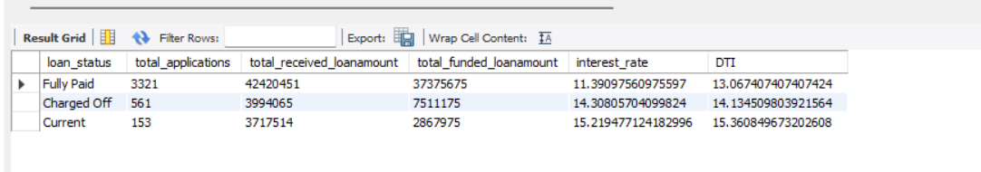

Bank Loan Report | Overview

MONTH

- Select monthname(str_to_date(issue_date, '%d-%m-%Y')) as month_name,
count(id) as total_loanapplications,
sum(loan_amount) as total_fundedamount,
sum(total_payment) as total_amountreceived
from bank_loandata
group by monthname(str_to_date(issue_date, '%d-%m-%Y')),
month(str_to_date(issue_date, '%d-%m-%Y'))
order by month(str_to_date(issue_date, '%d-%m-%Y'));

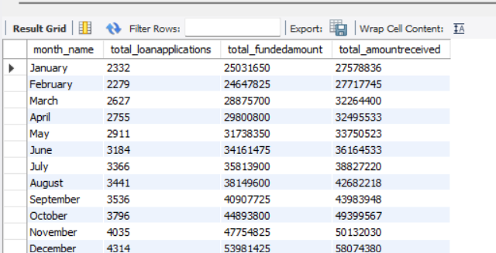

STATE

28) Select address_state,
count(id) as total_loanapplications,
sum(loan_amount) as total_fundedamount,
sum(total_payment) as total_amountreceived
from bank_loandata
group by address_state
order by count(id) desc;

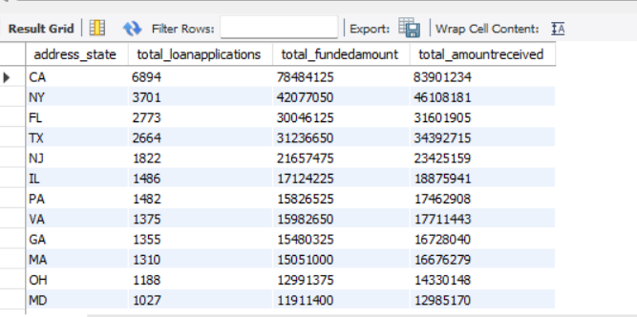

TERM

29)Select term,
count(id) as total_loanapplications,
sum(loan_amount) as total_fundedamount,
sum(total_payment) as total_amountreceived
from bank_loandata
group by term
order by term;

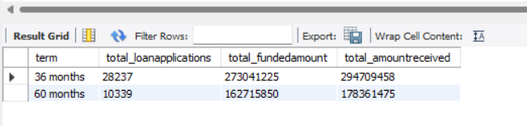
EMPLOYEE LENGTH
30) Select emp_length ,
count(id) as total_loanapplication,
sum(loan_amount) as total_fundedamount,
sum(total_payment) as total_receivedamt
from bank_loandata
group by emp_length
order by count(id) desc ;
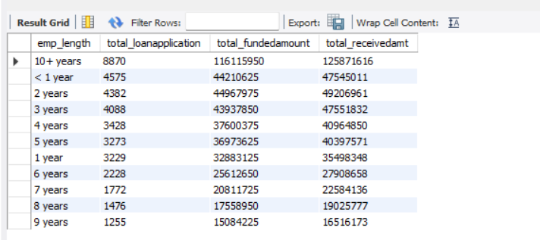

PURPOSE
31) Select purpose ,
count(id) as total_loanapplication,
sum(loan_amount) as total_fundedamount,
sum(total_payment) as total_receivedamt
from bank_loandata
group by purpose
order by count(id) desc ;
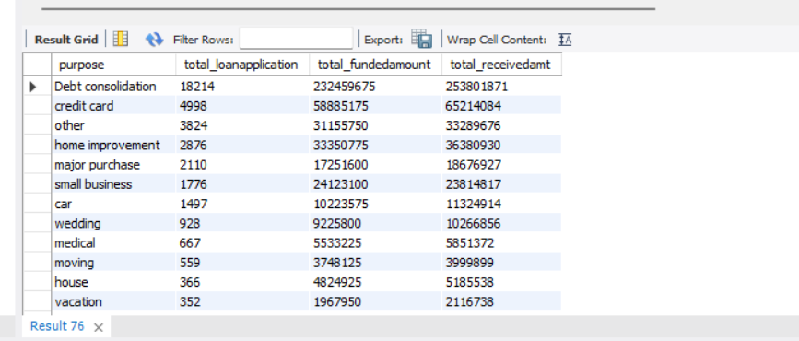

32) select home_ownership , count(id) as total_loan_application,
sum(loan_amount) as total_loan_fundedamount,
sum(total_payment) as total_loan_receivedamount
from bank_loandata
group by home_ownership
order by home_ownership;

